**GitHub code spaces workshop**

By Dr. Jignasha Dalal

Corporate Trainer

**Integrating GitHub code spaces with GitHub Classroom**

1. Open a personal GitHub account (existing account can be used) (https://github.com/join)
2. Visit <https://classroom.github.com/login>
3. Create classroom. You can create new classroom by clicking on “new classroom” button. Existing classrooms and assignments can also be viewed here.

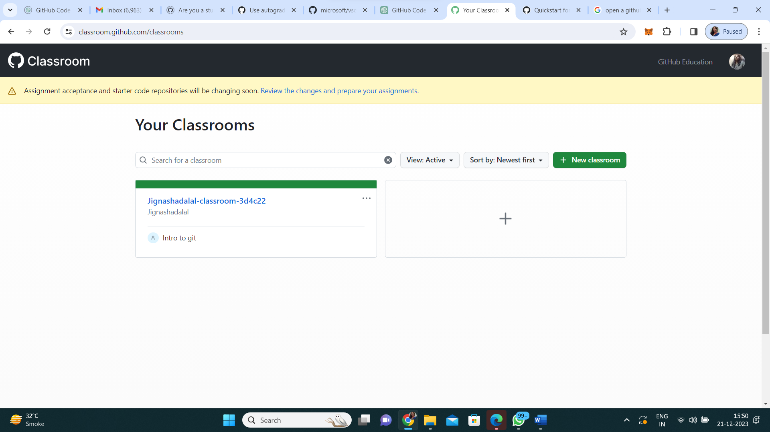

1. Create a new organisation or select an existing organisation

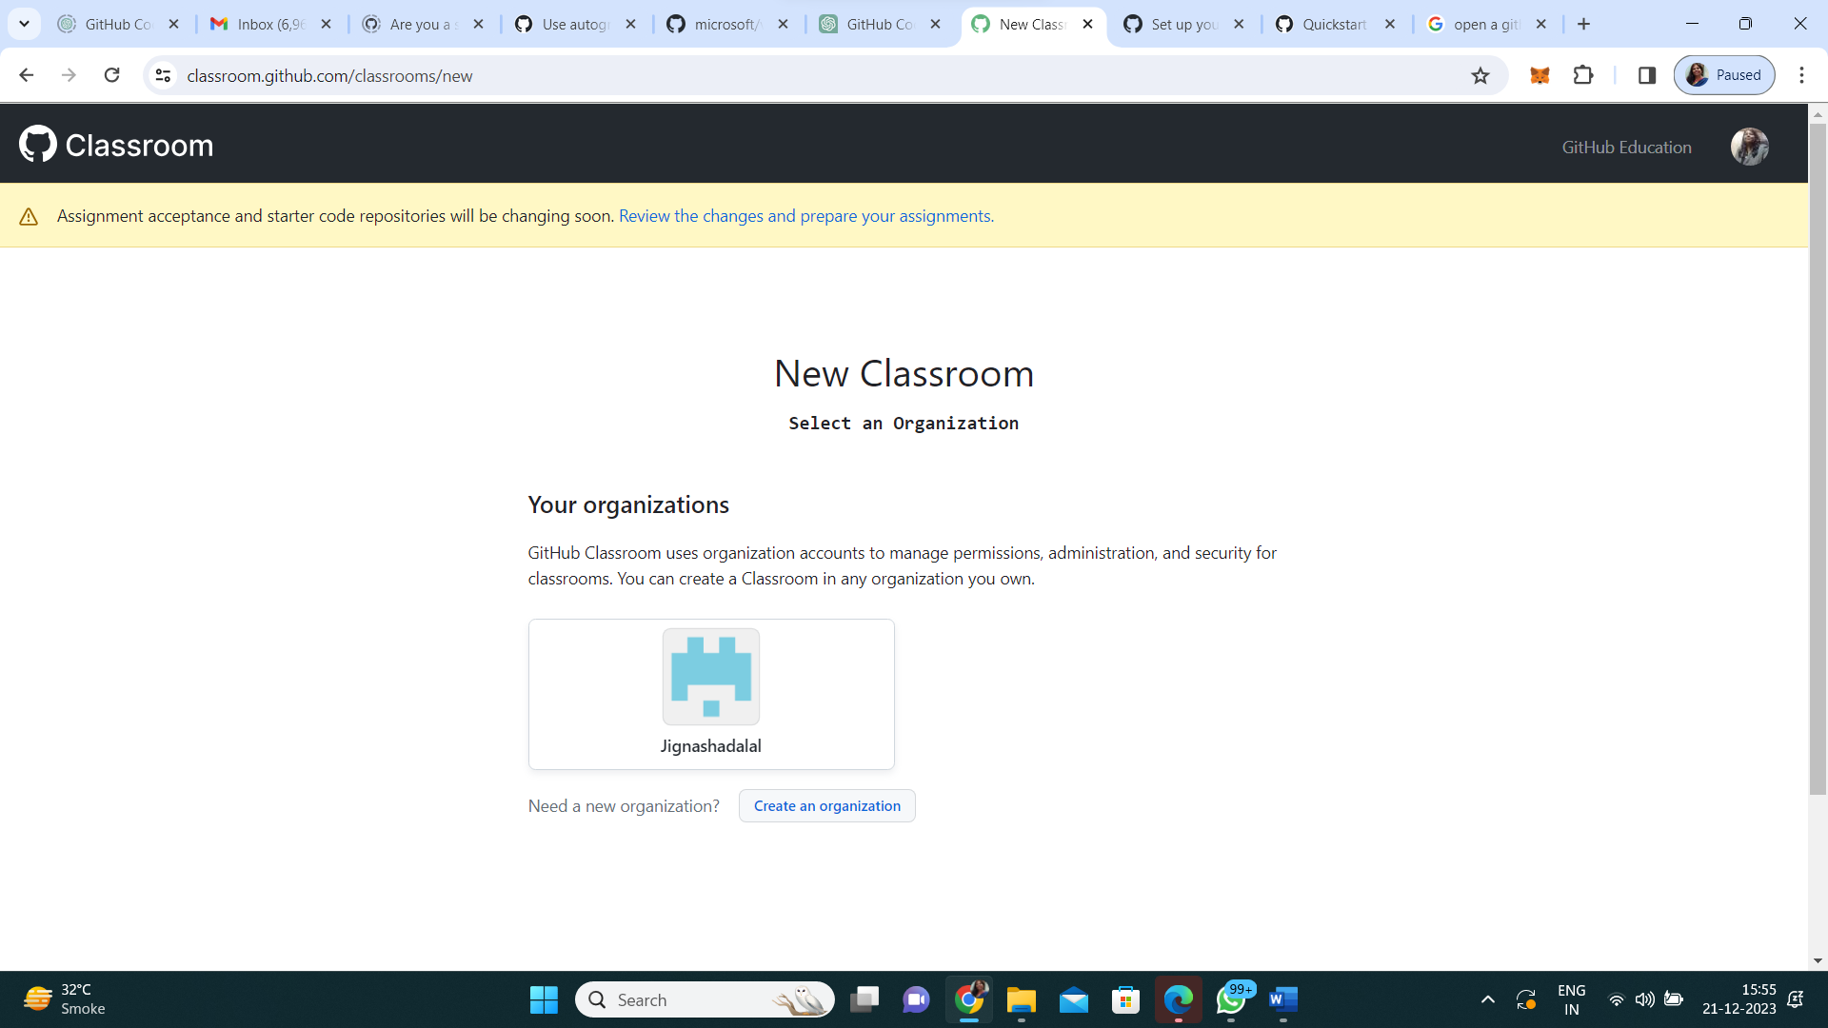

1. Set up an organisation

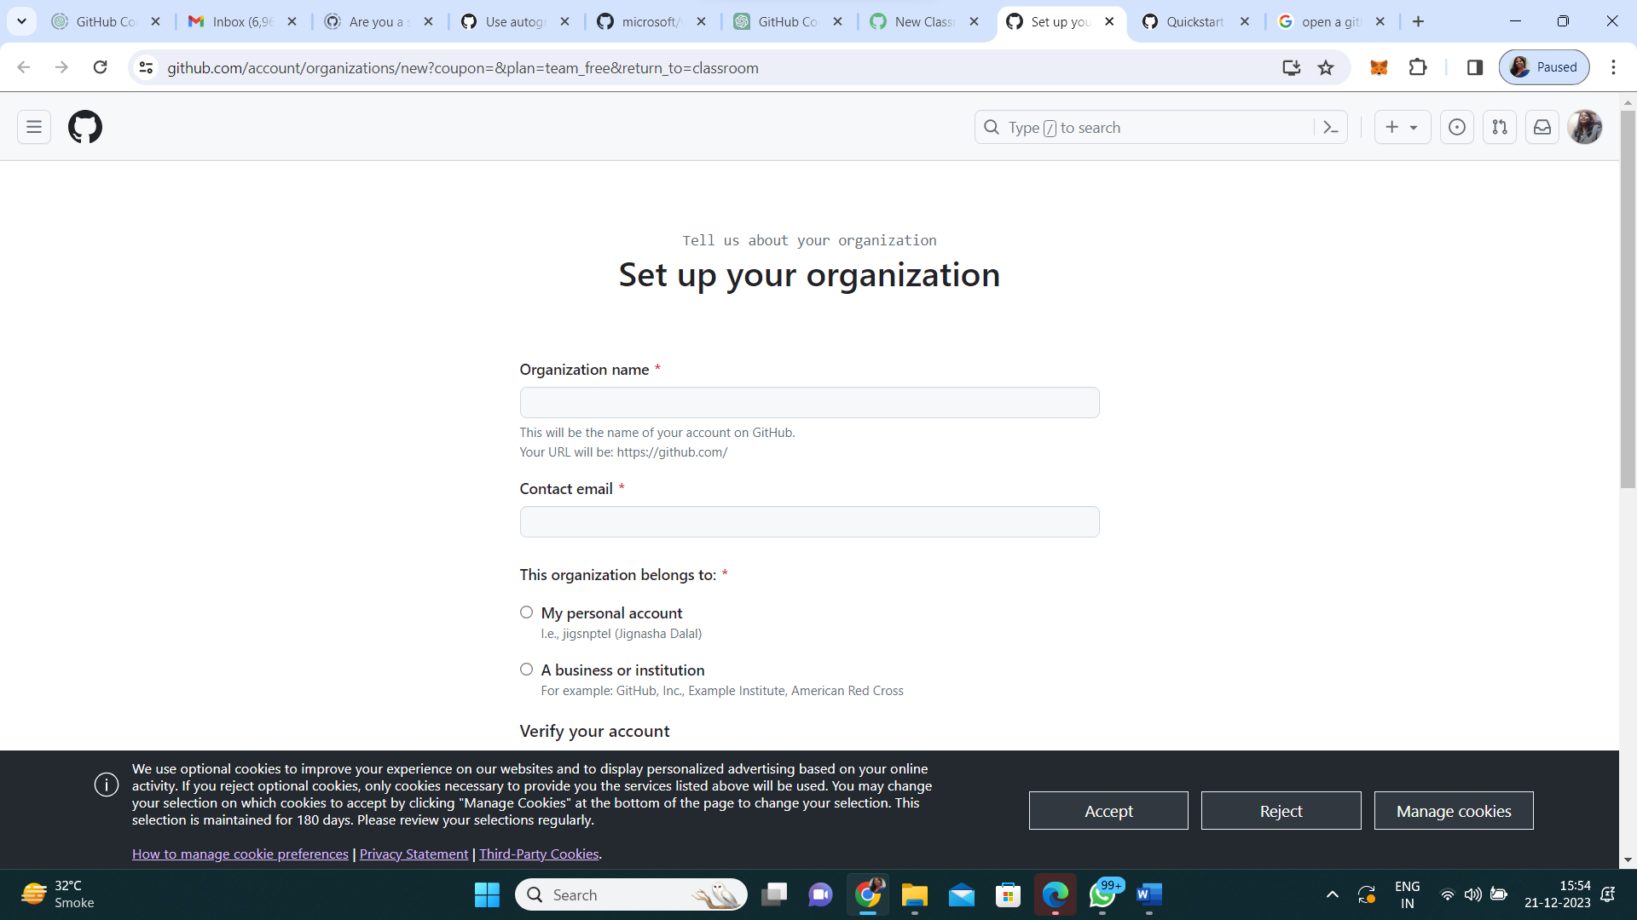

1. Select the organisation for creation of classroom and name the classroom and click on “create classroom”

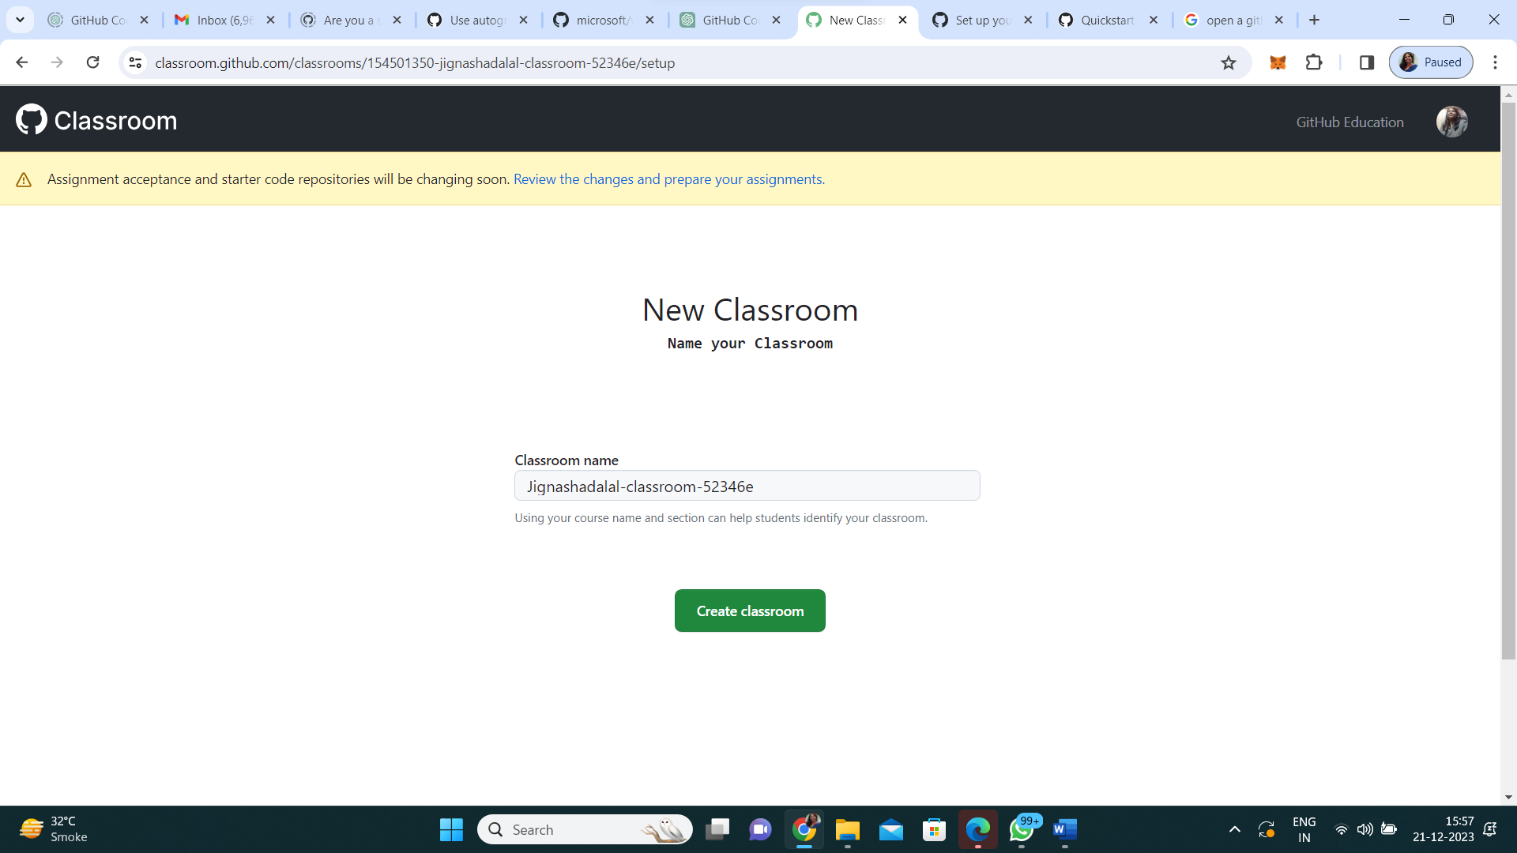

1. Invite TAs and admins and share classroom URL and click on “continue”

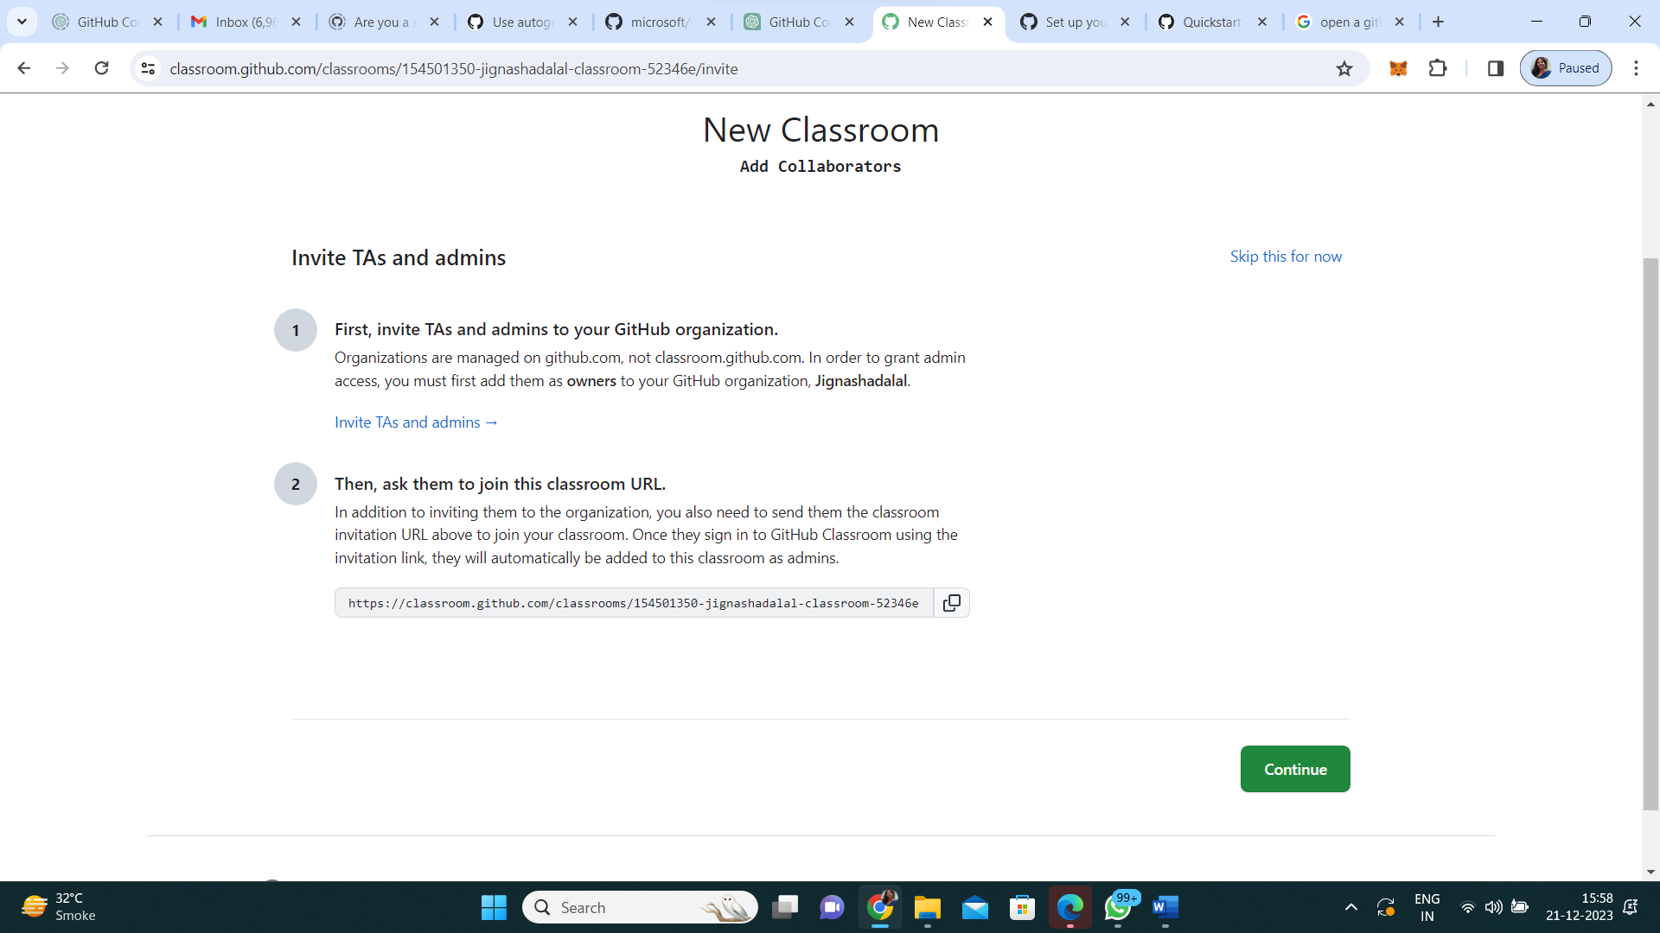

1. Add students to roster, you can connect to existing LMS, or google classroom or upload a excel or csv file or you can add students manually.

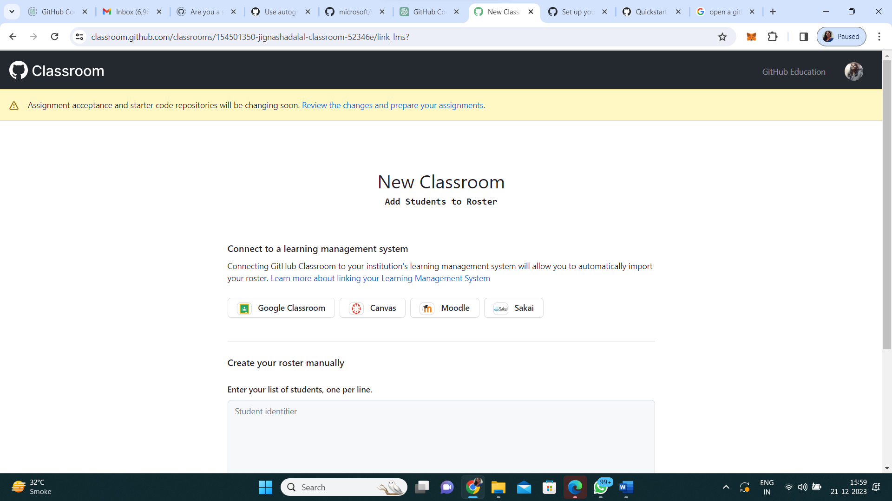

1. Get verified to enable GitHub code spaces. Organisation mail id and faculty ID clean image are required to get verified as GITHUB global campus teacher.

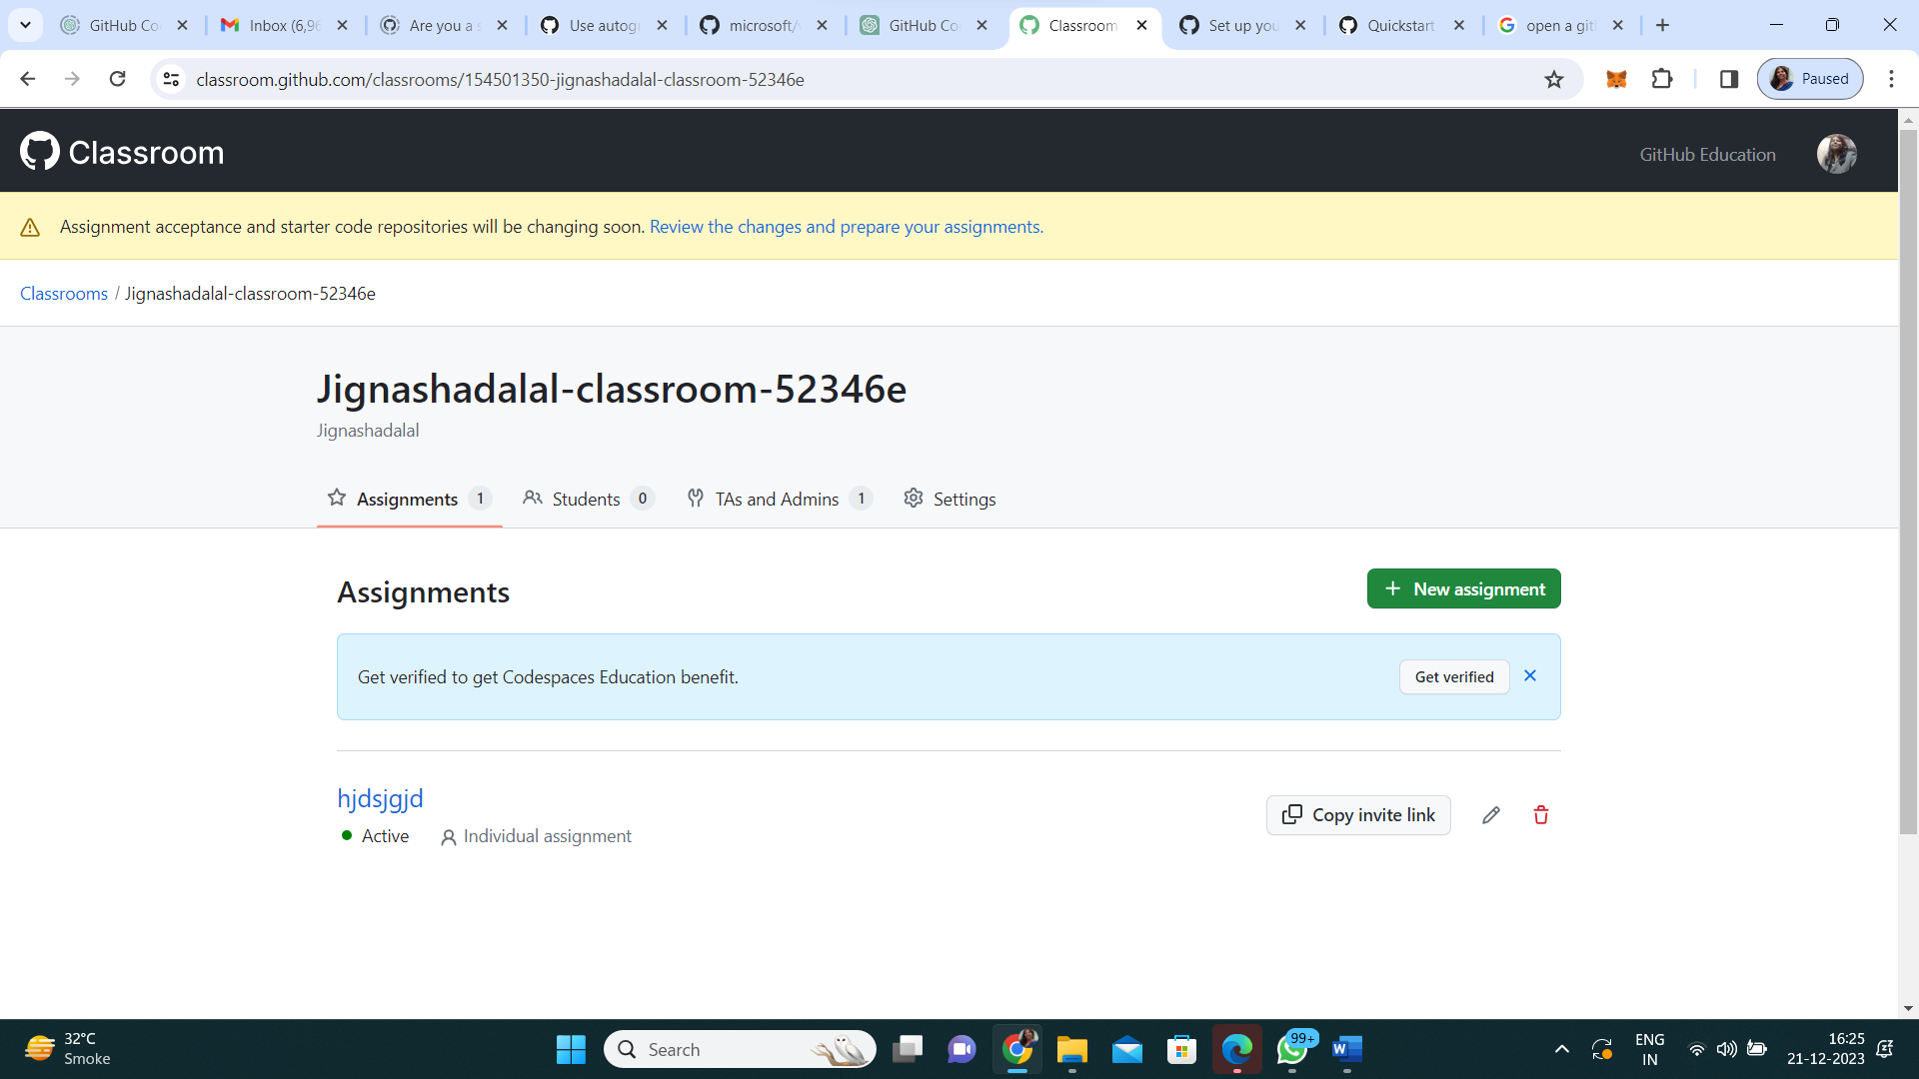

1. Select academic role (teacher or student)

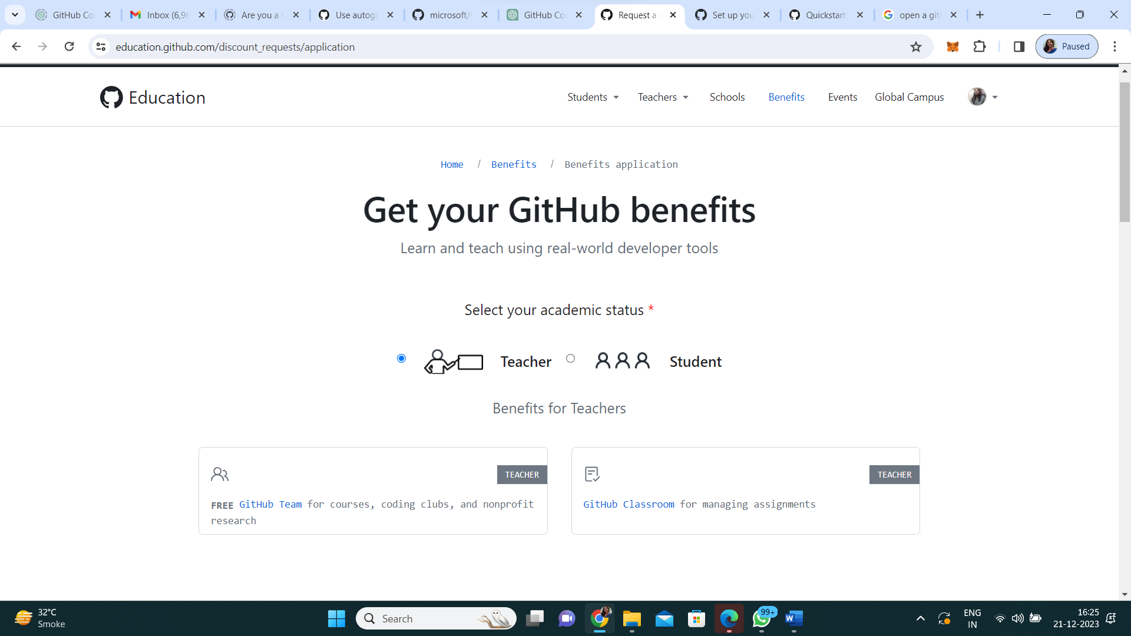

1. Follow the prompts and get verified. It may take 3-4 days to get approved. The approval will be sent on the mail. Once the approval is received, codespaces will be integrated with your classroom.
2. You can create individual/ group assignments. There are 3 steps on left side of panel for creating assignment namely assignment basics, starter code and environment and feedback and grading

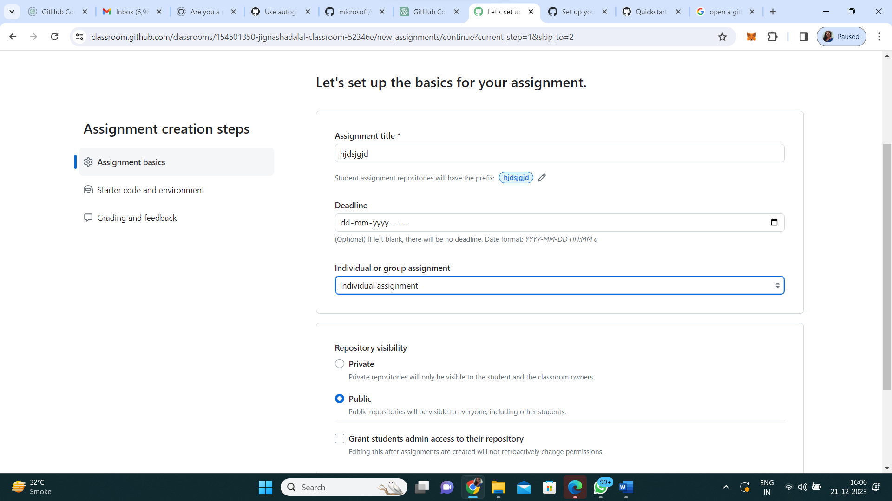

1. Follow all the prompts and create an assignment.
2. You can also create tests to autograde the assignments.